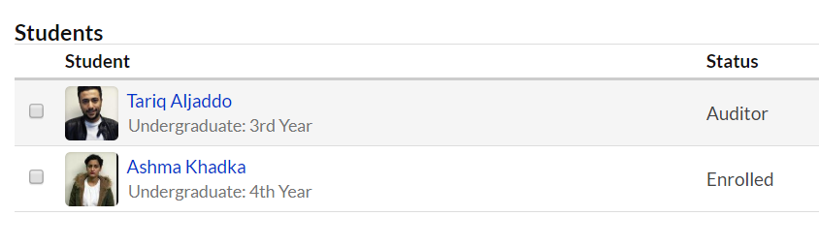

Tabular format: Rows and columns
FIRST_NAME | LAST_NAME | YEAR | STATUS
Tariq | Aljaddo | 3rd year | Auditor
Ashma | Khadka | 4th year | Enrolled

